CONFIDENTIAL | 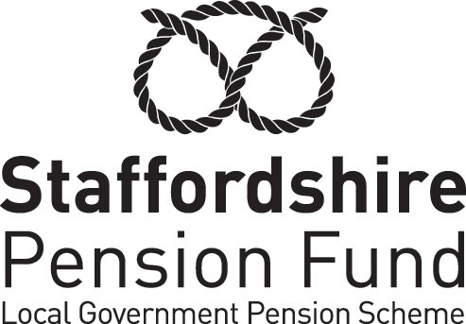

REQUEST FOR EARLY PAYMENT OF DEFERRED BENEFITS ON GROUNDS OF PERMANENT ILL-HEALTH

Your deferred benefits can be paid before Normal Pension Age (NPA) if:

- you have a breakdown in health to the extent that, had you still been employed, you would be permanently incapable of carrying out efficiently the duties of your employment (based on the medical evidence required by the Pension Scheme),

- in the case of a deferred pension awarded in respect of Scheme membership which ceased on or after 1 April 2008, as a result of your medical condition you have a reduced likelihood of being capable of undertaking any gainful employment (whether in local government or otherwise) before reaching normal retirement age or for at least 3 years, whichever is the sooner, and

- you request early payment of those benefits.

By completing the other side of this form you will be requesting payment of your deferred benefits on these grounds. On receipt of the form, your employer will make the appropriate arrangements for obtaining a medical opinion and will then decide whether or not the conditions for payment are satisfied.

If your employer decides that at the date of your request you are entitled to payment of your deferred benefits on health grounds, payment will be made with effect from that date.

If your employer decides that at the date of your request you are not entitled to immediate payment of your deferred benefits on health grounds, your employer will inform you of this and will tell you about your rights of appeal.

The completed form should be returned to :

Please read the notes on the other side of this form before completing this side.

REQUEST FOR EARLY PAYMENT OF DEFERRED BENEFITS ON GROUNDS OF PERMANENT ILL-HEALTH

- I am entitled to deferred benefits held in the Staffordshire County Pension Fund.

- I am not yet entitled to payment of the deferred benefits on grounds of age.

- I believe I have become permanently incapable of discharging efficiently the duties of my former employment (in respect of which I have entitlement to the deferred benefits) because of ill-health or infirmity of mind or body.

- (In the case of deferred benefits awarded in respect of Scheme membership which ceased on or after 1 April 2008.) My medical condition would prevent me from being capable of undertaking any gainful employment (whether in local government or otherwise) before reaching normal retirement age or for at least 3 years (whichever is the sooner).

- I request the early payment of the deferred benefits.

- I understand that this request will have effect subject to my former employer making a decision that I have entitlement to early payment of the deferred benefits after obtaining and considering the opinion of an independent registered medical practitioner who is qualified in occupational health medicine.

Signature ………………………………………………………. Date ……………………………………

Please complete in BLOCK CAPITALS

Surname ….…………………………………………………………………………………………………..

Forename(s) ………………………………………………………………………………………………….

Date of Birth ………………………………………………………………………………………………….

Maiden name/Previous name (if relevant) ………………………………………………………………...

Address ……………………………………………………………………………………………………….

…………………………………………………………………………………………………………………..

…………………………………………………………………………………………………………………..

Email Address……………………………………………………………………………………………..

If your address is likely to change in the near future please give details above

Last day of Local Government Pension Scheme membership …………………………………………

Employing body at the above date …………………………………………………………………………

Employment held at above date …………………………………………………………………………….

Personal Reference Number (given in letter of benefits entitlement) ……………………………….….

NPA is normally age 65 or the member’s individual State Pension Age (SPA) whichever is the later. A leaflet is available on our website called “State Pension Age” which provides further information if you are unsure what your NPA is. Please Note There are some deferred members who left the scheme prior to 30 September 2006 who have a protected NPA of between ages 60 to 65. Also, for Scheme members compulsorily transferred from the Learning and Skills Council for England on 1.4.2010, NPA would be age 60.

